A social class affects how you live and how you die. Social class and inequality impacts on different aspects of life. There are many spheres of modern life which are impacted by individual division of class. All these are somehow linked to wealth and poverty.

***Giddens (1998) - “There are few spheres in social life left untouched by class differences.”***

Each individual division of social class may impact many aspects of life but in this report four will be discuss. Health, Family life, Education, Crime and Judicial System.

**HEALTH AND SOCIAL CLASS**



Social Determinants of Health.

Persons health is impacted by low socio economic status. Lower class have less access to fresh things, exercise facilities, and awareness to preventative health programs that negatively impacts health outcomes. Health inequality refers to the unequal distribution of environmental hazards and access to health services between social classes. Lower class have more health problems as a result of their economic position and are unable to facilitate to use hath care services as often as upper or middle class does. Geographical area related to social class also affects health for example poorer neighborhoods have few grocery stores nearby that have good quality products and also have less recreational facilities like gyms parks playground and crime rate is also high than upper class area so which decreases the feasibility of daily routine exercise. Mental health also varies between class. Different class encounters different stressors. Lower class face stress of financial stability and everyday survival while upper class experience stress of social pressure associated with elite class. Upper class has more percentage of living longer than middle or working class the reason it quite obvious as upper class have more money and can afford.

**FAMILY LIFE AND SOCIAL CLASS**

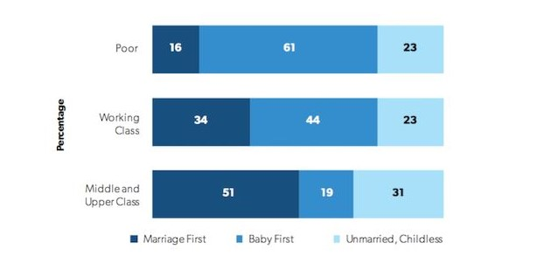

Family Paths and Social Class

Family life are impacted by social class. For example, different class have different parenting styles. An American sociologist Annett Lareau in her research found out different parenting style. She found out parents had different approaches in educating and disciplined their children. She observed that upper and middle class are much involved in student academic life and performance. They want their child to get admission in prestigious college and institutions and different home tuitions for their wellbeing on the other hand lower middle class fails to do so because of financial issues. In contrast middle class or working class has less time and money to structured kids in free time these kids likely to play and spend time neighborhood this affects upbringing of child but upper class even if they had no time they will make their kids to join institution to structure and make free time valuable. She also found that middle class parents work on obedience for example if they want them to do something they don’t had to question about it but upper class most likely to talk and make decisions. Today, less developed countries struggle with overpopulation while many governments in developed countries are instituting policies to deal with low birth rates.

**EDUCATION**

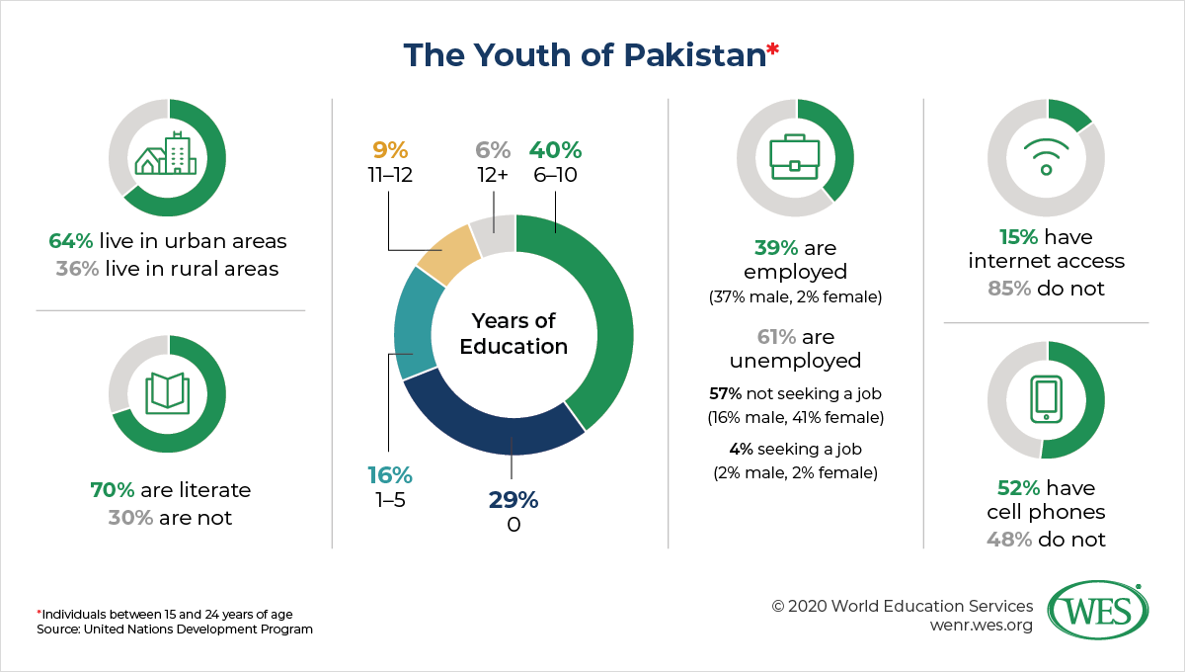

Education in Pakistan

Educational attainment is tied to social class; upper class acquire higher degrees from prestigious schools than lower class. Directly, in a way individuals from higher social classes are more likely to have the means to attend more prestigious schools, and are therefore more likely to receive higher educations. Indirectly, individuals who benefit from such higher education are more likely to land prestigious jobs, and in turn, higher salaries. Upper class prefers private education because of better educational facilities however lower class cannot afford and had to send their kids to government schools and colleges. And also social networks that are formed in the prestigious colleges also help in in jobs and financial success later. So it’s make difficult for lower socioeconomic status to move up the ladder. Without college degrees’ jobs are impossible to get and jobs u get without degree tends to give u less pay and have more occupational dangers. According to Alif Ailaan there are 25 million boys and girls between the ages of 5 and 16, who are out of school.

**CRIME, JUDICIAL SYSTEM AND SOCIAL CLASS**

Crime and Social class are connected in many number of ways. Crime appears to be strictly related to the level of education attained and to individuals’ economic and social background. positive relationship between crime rates and unemployment rate in Pakistan. Those from lower economic status are more likely to be arrested, convicted, and incarcerated for crimes than the individuals belonging to upper class. individuals are less likely to be caught and convicted of crimes. Additionally, white-collar crimes have traditionally been treated less severely by the criminal justice system than street crimes because of strong position of the upper class. The recent case happened with a girl named Noor Mukaddam who was brutally murdered by her boyfriend and her family still finding justice for her daughter but still no justice had been given even the social media and internet has videos of her murder but because of social status of convict the justice has not been given yets.

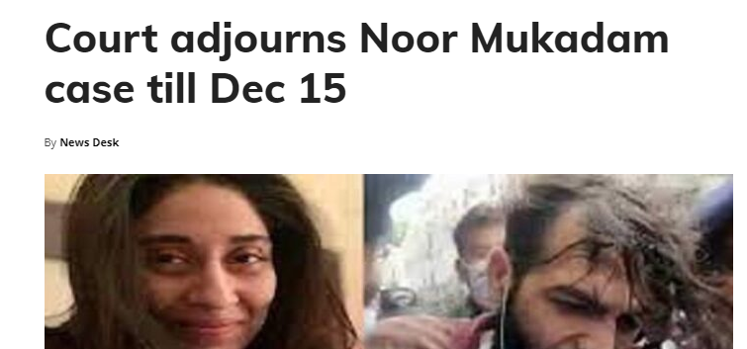

so crimes and social and economic factors are strongly related with each other.